1. Create virtual hosts mapped to the domain names webtech1.negotiage.org
   1. Within the document root of these virtual hosts, create two dummy files named content.html and content.txt. Configure the virtual hosts to enable clients to negotiate with the servers, using the HTTP Accept header, which of the two files is served when the clients access the URLs <http://webtech1.negotiage.org/content>
   2. Create two other dummy files, named language.html.en and language.html.fil, in the document roots of the virtual hosts and configure the virtual hosts to negotiate with the server, using the HTTP Accept-Language header, which of the two files is served when clients access the URLs <http://webtech1.negotiage.org/language.html>

**Create the First Virtual Host File**

Start by copying the file for the domain:

sudo cp /etc/apache2/sites-available/000-default.conf /etc/apache2/sites-available/webtech1.negotiage.org.conf

Open the new file in your editor with root privileges:

sudo nano /etc/apache2/sites-available/webtech1.negotiage.org.conf

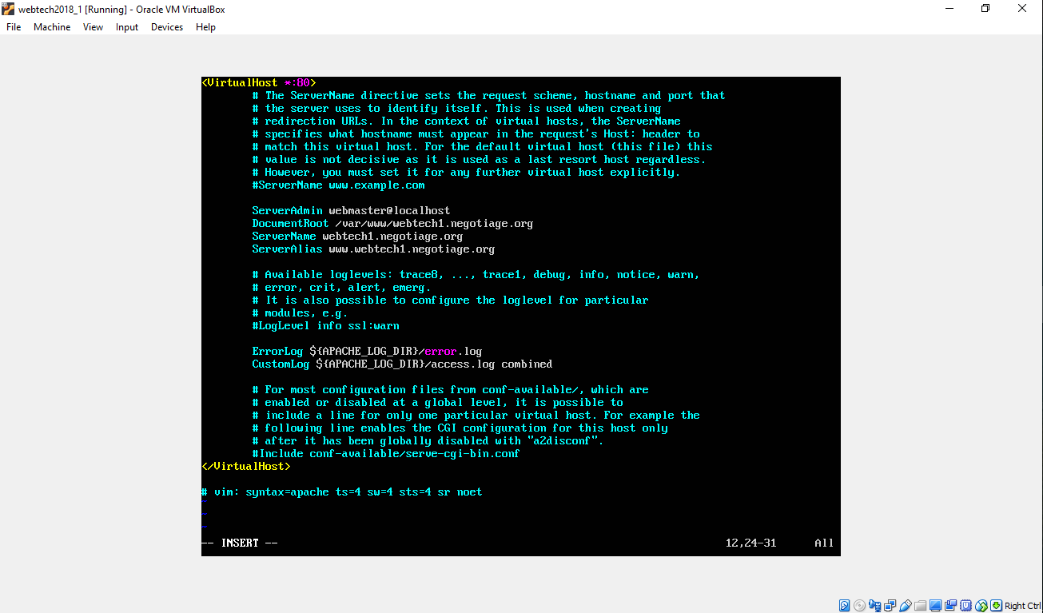

## **Enable the New Virtual Host Files**

Now that we have created our virtual host files, we must enable them. Apache includes some tools that allow us to do this.

We can use the a2ensite tool to enable each of our sites like this:

sudo a2ensite webtech1.negotiage.org.conf

When you are finished, you need to restart Apache to make these changes take effect:

sudo service apache2 restart

## **Set Up Local Hosts File**

sudo nano /etc/hosts

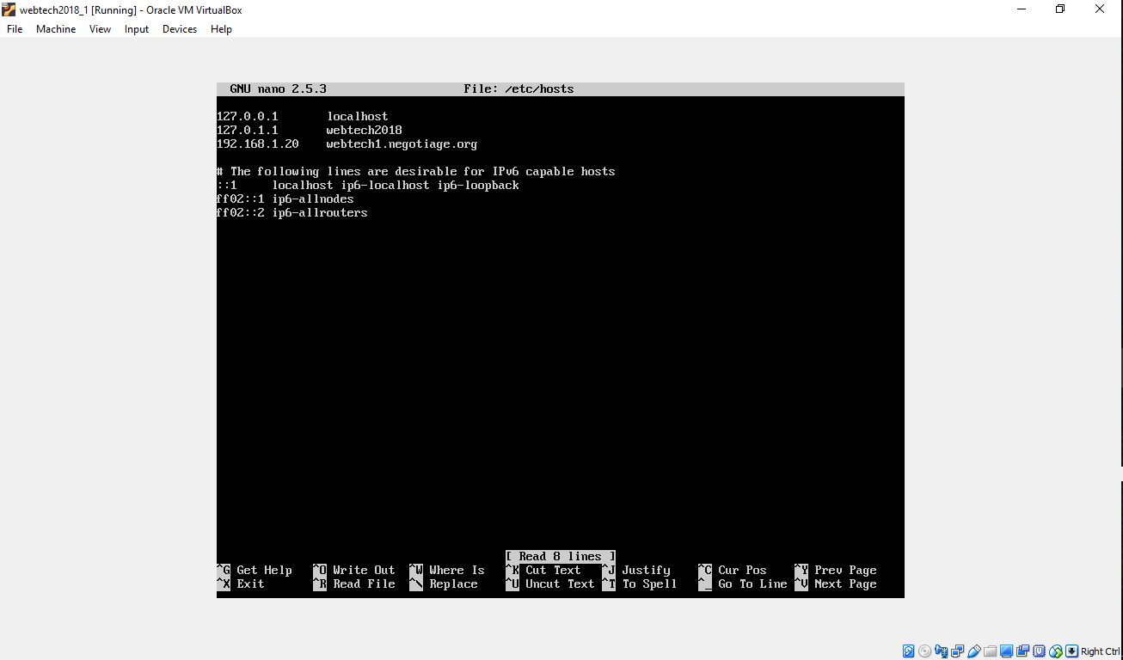

## **Create the Directory Structure**

sudo mkdir -p /var/www/webtech1.negotiage.org

## **Grant Permissions**

sudo chown -R $USER:$USER /var/www/webtech1.negotiage.org

sudo chmod -R 755 /var/www

## **Create Dummy Pages for Virtual Host**

nano /var/www/webtech1.negotiage.org/content.html

nano /var/www/webtech1.negotiage.org/content.txt

nano /var/www/webtech1.negotiage.org/language.html.en

nano /var/www/webtech1.negotiage.org/language.html.fil

## **Test Results**

Now that you have your virtual hosts configured, you can test your setup easily by going to the domains that you configured in your web browser:

